Exercise 8: Demo about Cards Column

Objectives and Outcomes

Bootstrap provides a built-in card component that allows you to create stylish and flexible cards for displaying content. Through this exercise, you can learn how a Bootstrap card is structured, including the use of various classes and elements such as card, card-img-top, card-body, card-title, card-text, and more

Exercises

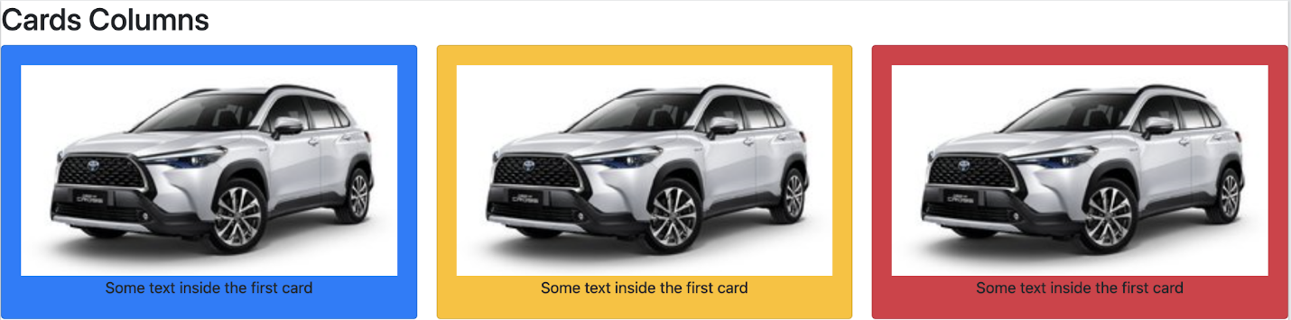

Conclusion

By working on exercises and exploring the Bootstrap documentation, you can further enhance your understanding and skills in using Bootstrap cards effectively